Chapter 2: Specification and Conception

2.1 Introduction
After presenting the general context of our project, we will dedicate this chapter to present our project in a formal way. We will do a detailed and complete analysis of different needs related to our application which will include:
- specifying the functional and non-functional requirements of our system.
-an identification of the main actors that are going to interact with our application.
-presentation of the global use case diagram
-presentation of different detailed use case diagrams

2.2 Functional requirements

In the following, we will present the functional requirements of our project.
Functional requirements express the actions that the system must execute in response to user requests. In our case, our application must respond to the following needs:

Registration
The application must allow users to register in order to access the application
Authentication
It allows the user to connect using his email address in order to benefit from the application’s features.
Consulting workout
It allows the user to open his account every day, and check his workout for that day.
Chat
It allows the user to connect and chat with other users.
Consulting support groups
It allows the user to consult available support groups and to join them
Creating support groups
It allows the user to create support groups and to invite people to these groups or make them public.
Settings:
It allows the use to consult or update settings
Goal:
It allows the user to consult or choose his goal.
Creating workout
It allows the Admin to create a workout
Consulting users
It allows the Admin to consult all the users
Changing user’s workout
It allows the admin to consult or change the user’s workout

2.3 Non-Functional requirements

We identify non-functional needs which are operational constraints that count on the performance of the application. They are summarized as follows:

- Scalability and maintenance: The application must be able to adapt to any change on the implementation side (updating frameworks) in order to guarantee its evolution and flexibility. Also, it must offer a clearly readable, understandable code and modular.

- Extensibility: The system must be scalable and must take into account the possibility of its extension by adding new features.

- Security: The Application must ensure the security of personal information

- Performance: The modules must optimize the treatments and reduce the execution time.

- Ergonomics: The application is user-friendly, simple to use, ergonomic and adapted to the use

- Reusability: The components of the system can be reused for the development of a different applications.

- Modularity: The application is well structured as modules to ensure better readability, a reduction in the risk of error and the possibility of selective tests

2.4 Use-case diagrams
A use case diagram is a behavior diagram that visualizes the observable interactions between actors and the system under development. The diagram consists of the system, the related use cases and actors.

In this section, we present the needs of our system in a formal way using the Unified Modeling Language (UML) use case diagrams. These various features are described in the diagrams below.

2.4.1 Global use-case diagram:

The Figure describes in a general way the actors of the system as well as the functionalities. A detailed description of the different use-case will follow.
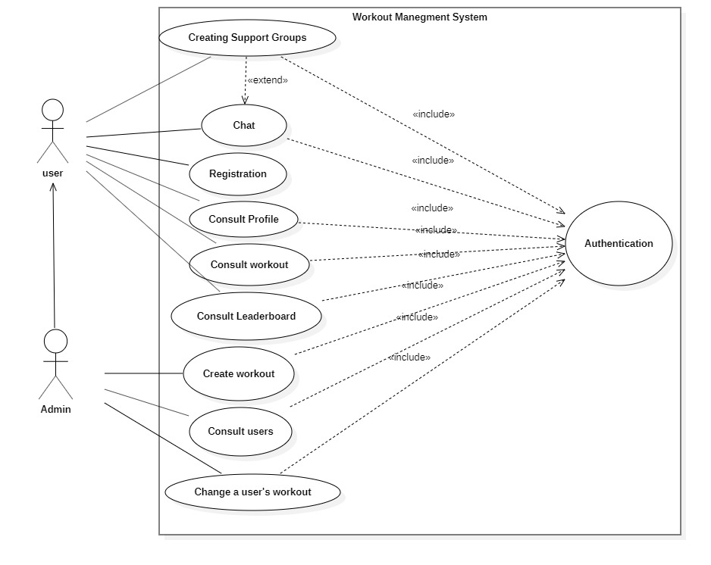

2.4.2 Authentication use-case diagram:

